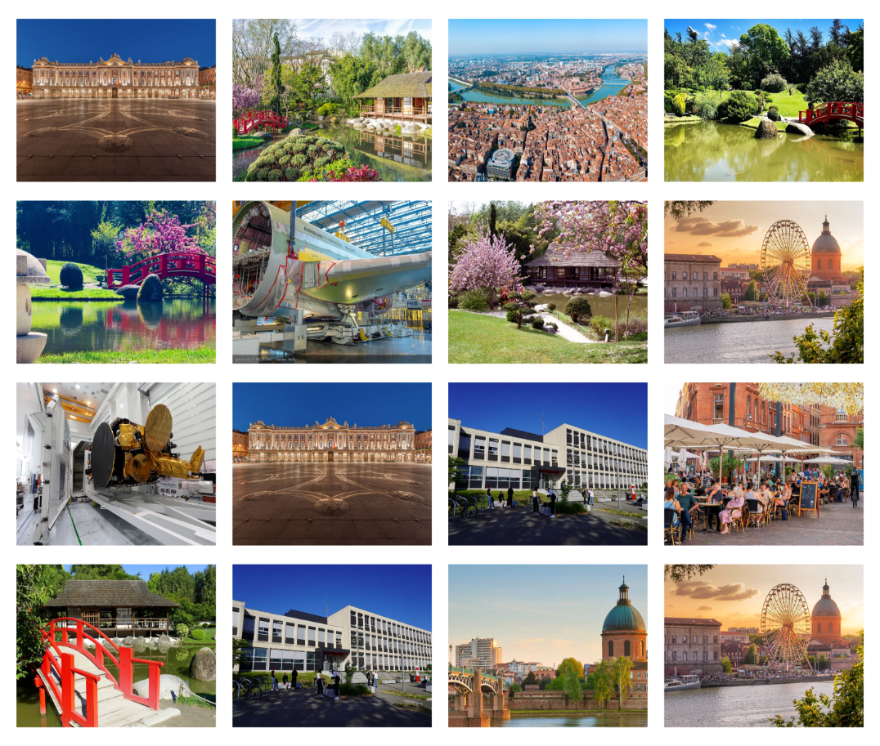

**The 28th IEEE International Symposium**

**On Real-Time Distributed Computing**

**IEEE ISORC 2025 (Hybrid Conference)**

**Toulouse, France**

**May 26-28, 2025**

<https://isorc.github.io/2025/>

**CALL FOR PAPERS**

**Organizing Committee**

**General Chairs**

**XX**

**Program Committee Chairs**

**XX**

**Steering Committee Chairs**

**Uwe Brinkschulte**

Goethe University of Frankfurt, Germany

**Robert G Pettit**

George Mason University, USA

**Local Management Chairs**

**XX**

**Web Chair**

**Akram Hakiri**

University of Pau & Pays de l’Adour, France.

**Publicity Chairs**

**XX**

**Publication Chairs**

**XX**

**Finance Chair**

**XX**

**Organizing Committee**

**Workshop chairs**

**XX**

**Short Paper/Poster chairs**

**XX**

**Tutorials chairs**

**XX**

**Keynote chairs**

**XX**

**Industry chairs**

**XX**

**Dissertation Digest chairs**

**XX**

**Doctoral Symposium chairs**

**XX**

**IEEE ISORC 2025**

ISORC has been established as the leading event devoted to state-of-the-art research and state-of-the-practice applications in the field of real-time distributed computing. Celebrating the 27th anniversary since its foundation in 1998, ISORC continues the trend of providing an international forum for researchers and industry experts to exchange and share their experiences, ideas, latest research results on all aspects of ORC technology.

**Topics**

IEEE ISORC 2025 invites high-quality papers on all aspects of ORC technology, including, but not limited to:

* *Software Architectures for Real-Time Distributed Computing.*
* *Distributed Real-Time Image, Video, and Stream Processing.*
* *Distributed Communication for Emerging and Future Networks.*
* *Blockchain and Distributed Ledger Technology (DLT) for Distributed Computing.*
* *AI/ML, LLM, and Federated Learning for Real-Time Distributed Computing.*
* *Digital Twin for Future Networks and Emerging IoT Applications*
* *Cybersecurity, and Trust for Distributed Real-Time IoT Systems.*
* *Optimization Approaches for Distributed Real-Time Computing in The Context of IoT, Cyber Physical Systems (CPS), and Edge-Cloud Continuum.*
* *Sustainable and Green Computing Transformation in Edge-to-Cloud Continuum.*
* *Formal Verification and Model Checking for Distributed Real-Time IoT, CPS, and Cloud.*
* *Ontology-Based Knowledge Modelling for Real-Time Distributed IoT & CPS.*
* *Dependability, Fault Tolerance, and Resilience of Distributed Real-Time IoT.*
* *Big Data, Algorithms, Models, and Techniques for Real-Time Analytics.*
* *Operating Systems, Middleware, and System Software.*
* *Distributed Management, Monitoring, Performance Evaluation.*
* *Applications for IoT, CPS, Edge-Cloud, Distributed Embedded Computing.*

**Guidelines for Manuscripts**

IEEE ISORC 2025 invites papers in the following categories:

* **Regular Research Papers:** Papers should describe original work and should be 10 pages maximum, plus two extra purchased pages for appendix and references.
* **Industrial Papers and Practitioner Reports:** Papers should be of 10 pages, plus 2 extra purchased pages for appendix and references**.** Papers describing experiences of using ORC technology in application or tool development projects, are an integral part of the technical program of ISORC.
* **Short Papers:** Short research papers, maximum 6 pages are also invited, and should contain enough information for the program committee to understand the scope of the project and evaluate the novelty of the problem or approach.

All papers should be formatted in the standard IEEE double-column format using the published [IEEE Conference Proceeding templates](http://www.ieee.org/conferences_events/conferences/publishing/templates.html), and submitted through the **HotCRP** system: <https://isorc25.hotcrp.com/>

**Important Dates**

* Submission deadline: January 08, 2025
* Acceptance notification: March 05, 2025
* Author registration deadline: March 16, 2025
* Camera-ready papers: March 20, 2025

**For more information**

More information about IEEE ISORC 2025, including submission guidelines, can be found at: [isorc.github.io/2024/](http://isorc.github.io/2025/)